**TASK 1**

mysql> create database dept;

Query OK, 1 row affected (0.22 sec)

mysql> use dept;

Database changed

mysql> create table dept(dno int primary key,dname varchar(20),loc varchar(10));

Query OK, 0 rows affected (0.49 sec)

mysql> desc dept;

+-------+-------------+------+-----+---------+-------+

| Field | Type | Null | Key | Default | Extra |

+-------+-------------+------+-----+---------+-------+

| dno | int | NO | PRI | NULL | |

| dname | varchar(20) | YES | | NULL | |

| loc | varchar(10) | YES | | NULL | |

+-------+-------------+------+-----+---------+-------+

3 rows in set (0.28 sec)

mysql> INSERT into dept(dno,dname, loc) VALUES(101,'computer','pune'),(102,'computer science','Mumbai'),(103,'Quality','London');

Query OK, 3 rows affected (0.18 sec)

Records: 3 Duplicates: 0 Warnings: 0

mysql> select * from dept;

+-----+------------------+--------+

| dno | dname | loc |

+-----+------------------+--------+

| 101 | computer | pune |

| 102 | computer science | Mumbai |

| 103 | Quality | London |

+-----+------------------+--------+

3 rows in set (0.00 sec)

mysql> create table emplo(eno int primary key,ename varchar(20),designation varchar(20),salary int,date_of_joining varchar(20),dno int references dept(dno));

Query OK, 0 rows affected (0.97 sec)

mysql> desc emplo;

+-----------------+-------------+------+-----+---------+-------+

| Field | Type | Null | Key | Default | Extra |

+-----------------+-------------+------+-----+---------+-------+

| eno | int | NO | PRI | NULL | |

| ename | varchar(20) | YES | | NULL | |

| designation | varchar(20) | YES | | NULL | |

| salary | int | YES | | NULL | |

| date_of_joining | varchar(20) | YES | | NULL | |

| dno | int | YES | | NULL | |

+-----------------+-------------+------+-----+---------+-------+

6 rows in set (0.00 sec)

mysql> insert into emplo(eno,ename,designation,salary,date_of_joining,dno)VALUES(1,'Sanika','Assistant',50000,'2020/01/01',101),(2,'Anita','CEO',2000,'2020/02/01',102),(3,'Pranita','Manager',90000,'2020/03/01',103),(4,'Vidhi','Tester',80000,'2020/04/01',104);

Query OK, 4 rows affected (0.12 sec)

Records: 4 Duplicates: 0 Warnings: 0

mysql> select * from emplo;

+-----+---------+-------------+--------+-----------------+------+

| eno | ename | designation | salary | date_of_joining | dno |

+-----+---------+-------------+--------+-----------------+------+

| 1 | Sanika | Assistant | 50000 | 2020/01/01 | 101 |

| 2 | Anita | CEO | 2000 | 2020/02/01 | 102 |

| 3 | Pranita | Manager | 90000 | 2020/03/01 | 103 |

| 4 | Vidhi | Tester | 80000 | 2020/04/01 | 104 |

+-----+---------+-------------+--------+-----------------+------+

4 rows in set (0.00 sec)

**Q 1. Add column Phone_no into emp table with data type int.**

mysql> alter table emplo

-> add phone_no int(11);

Query OK, 0 rows affected, 1 warning (0.37 sec)

Records: 0 Duplicates: 0 Warnings: 1

mysql> desc emplo;

+-----------------+-------------+------+-----+---------+-------+

| Field | Type | Null | Key | Default | Extra |

+-----------------+-------------+------+-----+---------+-------+

| eno | int | NO | PRI | NULL | |

| ename | varchar(20) | YES | | NULL | |

| designation | varchar(20) | YES | | NULL | |

| salary | int | YES | | NULL | |

| date_of_joining | varchar(20) | YES | | NULL | |

| dno | int | YES | | NULL | |

| phone_no | int | YES | | NULL | |

+-----------------+-------------+------+-----+---------+-------+

7 rows in set (0.03 sec)

**Q 2.Update Phone_no.**

mysql> alter table emplo

-> add phone_no int(11);

Query OK, 0 rows affected, 1 warning (0.37 sec)

Records: 0 Duplicates: 0 Warnings: 1

mysql> desc emplo;

+-----------------+-------------+------+-----+---------+-------+

| Field | Type | Null | Key | Default | Extra |

+-----------------+-------------+------+-----+---------+-------+

| eno | int | NO | PRI | NULL | |

| ename | varchar(20) | YES | | NULL | |

| designation | varchar(20) | YES | | NULL | |

| salary | int | YES | | NULL | |

| date_of_joining | varchar(20) | YES | | NULL | |

| dno | int | YES | | NULL | |

| phone_no | int | YES | | NULL | |

+-----------------+-------------+------+-----+---------+-------+

7 rows in set (0.03 sec)

**Q 2.Update Phone_no.**

mysql> update emplo

-> set phone_no=1987654321

-> where eno=1;

Query OK, 1 row affected (0.09 sec)

Rows matched: 1 Changed: 1 Warnings: 0

mysql> update emplo

-> set phone_no=1234567890

-> where eno=2;

Query OK, 1 row affected (0.13 sec)

Rows matched: 1 Changed: 1 Warnings: 0

mysql> update emplo

-> set phone_no=234567891

-> where eno=3;

Query OK, 1 row affected (0.09 sec)

Rows matched: 1 Changed: 1 Warnings: 0

mysql> update emplo

-> set phone_no=345678912

-> where eno=4;

Query OK, 1 row affected (0.10 sec)

Rows matched: 1 Changed: 1 Warnings: 0

mysql> select * from emplo;

+-----+---------+-------------+--------+-----------------+------+------------+

| eno | ename | designation | salary | date_of_joining | dno | phone_no |

+-----+---------+-------------+--------+-----------------+------+------------+

| 1 | Sanika | Assistant | 50000 | 2020/01/01 | 101 | 1987654321 |

| 2 | Anita | CEO | 2000 | 2020/02/01 | 102 | 1234567890 |

| 3 | Pranita | Manager | 90000 | 2020/03/01 | 103 | 234567891 |

| 4 | Vidhi | Tester | 80000 | 2020/04/01 | 104 | 345678912 |

+-----+---------+-------------+--------+-----------------+------+------------+

4 rows in set (0.00 sec)

**Q 3. Delete the details of employee whose designation is manager.**

mysql> DELETE from emplo WHERE designation ='Manager';

Query OK, 1 row affected (0.14 sec)

mysql> select* from emplo;

+-----+--------+-------------+--------+-----------------+------+------------+

| eno | ename | designation | salary | date_of_joining | dno | phone_no |

+-----+--------+-------------+--------+-----------------+------+------------+

| 1 | Sanika | Assistant | 50000 | 2020/01/01 | 101 | 1987654321 |

| 2 | Anita | CEO | 2000 | 2020/02/01 | 102 | 1234567890 |

| 4 | Vidhi | Tester | 80000 | 2020/04/01 | 104 | 345678912 |

+-----+--------+-------------+--------+-----------------+------+------------+

3 rows in set (0.00 sec)

**Q 4. Display the count of employee department wise.**

mysql> select count(eno),dname

-> from emplo,dept

-> where emplo.dno=dept.dno

-> group by dname;

+------------+------------------+

| count(eno) | dname |

+------------+------------------+

| 1 | computer |

| 1 | computer science |

+------------+------------------+

2 rows in set (0.00 sec)

**Q 5. Display the count of employee department**

mysql> select ename,dname

-> from emplo,dept

-> where emplo.dno=dept.dno and designation='ceo' and dname='computer';

Empty set (0.00 sec)

**Q 6. Display the name of employee who is ‘CEO’ of ‘account ‘Computer Science’.**

mysql> select ename,dname

-> from emplo,dept

-> where emplo.dno=dept.dno and designation='ceo'and dname='computer science';

+-------+------------------+

| ename | dname |

+-------+------------------+

| Anita | computer science |

+-------+------------------+

1 row in set (0.00 sec)

**Q 7. Display the name of department whose location is ‘pune’ of sanika is working it.**

mysql> select ename,dname

-> from emplo,dept

-> where emplo.dno=dept.dno and loc='pune' and ename='sanika';

+--------+----------+

| ename | dname |

+--------+----------+

| Sanika | computer |

+--------+----------+

1 row in set (0.00 sec)

**Q 9. Display the names of employee whose salary is greater then 50000 and department is ’Quality’.**

mysql> select ename,dname

-> from emplo,dept

-> where emplo.dno=dept.dno and salary>90000 and dname='quality';

Empty set (0.00 sec)

**Q 10. Update date of joining of employee to’15/06/2019’ whose department is ‘computer science’and name is ‘angha’.**

mysql> UPDATE emplo set date_of_joining='2019/06/15' where dno=(select dno FROM dept WHERE dname='Computeer science') AND ename='angha';

Query OK, 0 rows affected (0.00 sec)

Rows matched: 0 Changed: 0 Warnings: 0

mysql> select * from emplo;

+-----+--------+-------------+--------+-----------------+------+------------+

| eno | ename | designation | salary | date_of_joining | dno | phone_no |

+-----+--------+-------------+--------+-----------------+------+------------+

| 1 | Sanika | Assistant | 50000 | 2020/01/01 | 101 | 1987654321 |

| 2 | Anita | CEO | 2000 | 2020/02/01 | 102 | 1234567890 |

| 4 | Vidhi | Tester | 80000 | 2020/04/01 | 104 | 345678912 |

+-----+--------+-------------+--------+-----------------+------+------------+

3 rows in set (0.00 sec)

**TASK 2**

mysql> create database Sales_order;

Query OK, 1 row affected (0.13 sec)

mysql> use Sales_order;

Database changed

mysql> create table Sales_order(ordNo int,ordDate int,Sales_order int);

Query OK, 0 rows affected (0.46 sec)

mysql> desc Sales_order;

+-------------+------+------+-----+---------+-------+

| Field | Type | Null | Key | Default | Extra |

+-------------+------+------+-----+---------+-------+

| ordNo | int | YES | | NULL | |

| ordDate | int | YES | | NULL | |

| Sales_order | int | YES | | NULL | |

+-------------+------+------+-----+---------+-------+

3 rows in set (0.06 sec)

mysql> alter table sales_order

-> add sales_amt float;

Query OK, 0 rows affected (0.59 sec)

Records: 0 Duplicates: 0 Warnings: 0

mysql> desc sales_order;

+-------------+-------+------+-----+---------+-------+

| Field | Type | Null | Key | Default | Extra |

+-------------+-------+------+-----+---------+-------+

| ordNo | int | YES | | NULL | |

| ordDate | int | YES | | NULL | |

| Sales_order | int | YES | | NULL | |

| sales_amt | float | YES | | NULL | |

+-------------+-------+------+-----+---------+-------+

4 rows in set (0.00 sec)

mysql> insert into sales_order(ordno,ordDate,sales_order,sales_amt)values(101,2020-3-4,2,1000),(102,2019-1-4,3,3000),(103,2021-1-5,2,1200),(104,2020-4-4,2,1100);

Query OK, 4 rows affected (0.10 sec)

Records: 4 Duplicates: 0 Warnings: 0

mysql> select * from sales_order;

+-------+---------+-------------+-----------+

| ordNo | ordDate | Sales_order | sales_amt |

+-------+---------+-------------+-----------+

| 101 | 2013 | 2 | 1000 |

| 102 | 2014 | 3 | 3000 |

| 103 | 2015 | 2 | 1200 |

| 104 | 2012 | 2 | 1100 |

+-------+---------+-------------+-----------+

4 rows in set (0.00 sec)

mysql> create database client;

mysql> use client;

Database changed

mysql> create table client(clientno int primary key,clientname varchar(20),Addr varchar(20));

Query OK, 0 rows affected (0.54 sec)

mysql> desc client;

+------------+-------------+------+-----+---------+-------+

| Field | Type | Null | Key | Default | Extra |

+------------+-------------+------+-----+---------+-------+

| clientno | int | NO | PRI | NULL | |

| clientname | varchar(20) | YES | | NULL | |

| Addr | varchar(20) | YES | | NULL | |

+------------+-------------+------+-----+---------+-------+

3 rows in set (0.00 sec)

Query OK, 1 row affected (0.13 sec)

mysql> use client;

Database changed

mysql> create table sales_order(ordNo int,ordDate int,Sales_order int);

Query OK, 0 rows affected (0.35 sec)

mysql> desc sales_order;

+-------------+------+------+-----+---------+-------+

| Field | Type | Null | Key | Default | Extra |

+-------------+------+------+-----+---------+-------+

| ordNo | int | YES | | NULL | |

| ordDate | int | YES | | NULL | |

| Sales_order | int | YES | | NULL | |

+-------------+------+------+-----+---------+-------+

3 rows in set (0.00 sec)

mysql> insert into client(clientNo,clientName,Addr)values(101,'Anuu','Pune'),(102,'Anushka','Satara'),(103,'Radha','Landan');

Query OK, 3 rows affected (0.12 sec)

Records: 3 Duplicates: 0 Warnings: 0

mysql> select * from client;

+----------+------------+--------+

| clientno | clientname | Addr |

+----------+------------+--------+

| 101 | Anuu | Pune |

| 102 | Anushka | Satara |

| 103 | Radha | Landan |

+----------+------------+--------+

3 rows in set (0.00 sec)

**1.Add column amount into sales_order table with data tyape Float.**

mysql> alter table sales_order

-> add sales_amt float;

Query OK, 0 rows affected (0.24 sec)

Records: 0 Duplicates: 0 Warnings: 0

mysql> desc sales_order;

+-------------+-------+------+-----+---------+-------+

| Field | Type | Null | Key | Default | Extra |

+-------------+-------+------+-----+---------+-------+

| ordNo | int | YES | | NULL | |

| ordDate | int | YES | | NULL | |

| Sales_order | int | YES | | NULL | |

| sales_amt | float | YES | | NULL | |

+-------------+-------+------+-----+---------+-------+

4 rows in set (0.00 sec)

**2.Delete the details of the clients whoses start with ‘A’ character.**

mysql> delete from client

-> where clientName like'A%';

Query OK, 2 rows affected (0.11 sec)

mysql> select * from client;

+----------+------------+--------+

| clientno | clientname | Addr |

**3 .Delete sales order details of client whose name is ‘Anuu’ and order is “2012’’.**

mysql> DELETE client, sales_order FROM client, sales_order WHERE client.clientNo = sales_order.clientNo AND clientname = 'Anuu' AND sales_order.ordDate = '2012';

Query OK, 0 rows affected (0.00 sec)

mysql> select* from client;

+----------+------------+--------+

| clientNo | clientName | Addr |

+----------+------------+--------+

| 101 | Anuu | Pune |

| 102 | Anushka | Satara |

| 103 | Radha | Landan |

+----------+------------+--------+

3 rows in set (0.00 sec)

**4. Change address of clientNo’102’ ,‘Dubai’.**

mysql> update client set Addr='dubai' where clientNo=102;

Query OK, 0 rows affected (0.00 sec)

Rows matched: 0 Changed: 0 Warnings: 0

mysql> select * from client;

+----------+------------+--------+

| clientno | clientname | Addr |

+----------+------------+--------+

| 103 | Radha | Landan |

+----------+------------+--------+

1 row in set (0.00 sec)

+----------+------------+--------+

| 103 | Radha | Landan |

+----------+------------+--------+

1 row in set (0.00 sec)

**5. Delete all sales_record having order date is before’2014’**

mysql> delete from sales_order

-> where orddate<'2014';

Query OK, 2 rows affected (0.01 sec)

mysql> select* from sales_order;

+-------+---------+-------------+-----------+----------+

| ordno | ordDate | Sales_order | sales_amt | clientNo |

+-------+---------+-------------+-----------+----------+

| 102 | 2014 | 3 | 3000 | 102 |

| 103 | 2015 | 2 | 1200 | 103 |

+-------+---------+-------------+-----------+----------+

2 rows in set (0.00 sec)

**6. Update the address of client to’mumbai’ whose clientno=101;**

mysql> update client

-> set addr='mumbai'

-> where clientNo=101;

Query OK, 1 row affected (0.01 sec)

Rows matched: 1 Changed: 1 Warnings: 0

mysql> select* from client;

+----------+------------+--------+

| clientNo | clientName | Addr |

+----------+------------+--------+

| 101 | Anuu | mumbai |

| 102 | Anushka | dubai |

| 103 | Radha | Landan |

+----------+------------+--------+

3 rows in set (0.00 sec)

**7. display totals ordes 2014.**

mysql> select count(*) as Total

-> from sales_order,client

-> where client.clientNo=sales_order.clientNo and orddate=2014;

+-------+

| Total |

+-------+

| 1 |

+-------+

1 row in set (0.00 sec)

**8. Display totals sale amount between 2014 to 2015.**

mysql> select sum(sales_amt)As sales_order

-> from sales_order

-> where orddate>='2014' and orddate<='2015';

+-------------+

| sales_order |

+-------------+

| 4200 |

+-------------+

1 row in set (0.00 sec)

**9. Display total no customers from dubai location.**

where addr='dubai'' at line 1

mysql> SELECT COUNT(*) AS total_clientname FROM client WHERE addr = 'dubai';

+------------------+

| total_clientname |

+------------------+

| 1 |

+------------------+

1 row in set (0.00 sec)

**TASK 3**

mysql> USE hospital1;

Database changed

mysql> DESC hospital1;

+----------+-------------+------+-----+---------+-------+

| Field | Type | Null | Key | Default | Extra |

+----------+-------------+------+-----+---------+-------+

| hno | int | YES | | NULL | |

| hname | varchar(20) | YES | | NULL | |

| city | varchar(20) | YES | | NULL | |

| Est_year | int | YES | | NULL | |

| Addr | varchar(20) | YES | | NULL | |

+----------+-------------+------+-----+---------+-------+

5 rows in set (0.05 sec)

mysql> select * from hospital1;

+------+-----------+----------+----------+-------------+

| hno | hname | city | Est_year | Addr |

+------+-----------+----------+----------+-------------+

| 101 | Krishna | satara | 2000 | vaduj |

| 102 | BJ Katkar | Sangli | 2012 | Katraj |

| 103 | Sanjivan | Pune | 2012 | Dahiwadi |

| 104 | Spandan | Kolhapur | 2022 | Katarkhatav |

| 105 | Bharti | Pune | 2024 | Vaduj |

| 106 | Deva | Beed | 2018 | Dhane |

| 107 | Kaji | Solapur | 2023 | karad |

+------+-----------+----------+----------+-------------+

7 rows in set (0.00 sec)

mysql> insert into DOCTOR1(Dno,Dname,Addr,Speaciality,Salary,hno)VALUES

-> (1,'Vaibhav','satara','Teeth',70000,101),

-> (2,'Shubham','Pune','Eyes',80000,102),

-> (3,'Pawan','Solapur','Skin',50000,103),

-> (4,'Amit','Thane','Ears',90000,104),

-> (5,'Tejas','Mumbai','Bone',55000,105);

Query OK, 5 rows affected (0.28 sec)

Records: 5 Duplicates: 0 Warnings: 0

mysql> desc DOCTOR1;

+-------------+-------------+------+-----+---------+-------+

| Field | Type | Null | Key | Default | Extra |

+-------------+-------------+------+-----+---------+-------+

| Dno | int | YES | | NULL | |

| Dname | varchar(20) | YES | | NULL | |

| Addr | varchar(20) | YES | | NULL | |

| Speaciality | varchar(52) | YES | | NULL | |

| Salary | int | YES | | NULL | |

| hno | int | YES | | NULL | |

+-------------+-------------+------+-----+---------+-------+

6 rows in set (0.00 sec)

mysql> SELECT * from DOCTOR1;

+------+---------+---------+-------------+--------+------+

| Dno | Dname | Addr | Speaciality | Salary | hno |

+------+---------+---------+-------------+--------+------+

| 1 | Vaibhav | satara | Teeth | 70000 | 101 |

| 2 | Shubham | Pune | Eyes | 80000 | 102 |

| 3 | Pawan | Solapur | Skin | 50000 | 103 |

| 4 | Amit | Thane | Ears | 90000 | 104 |

| 5 | Tejas | Mumbai | Bone | 55000 | 105 |

+------+---------+---------+-------------+--------+------+

5 rows in set (0.00 sec)

**Q 1.Delete Add column from Hospital table.**

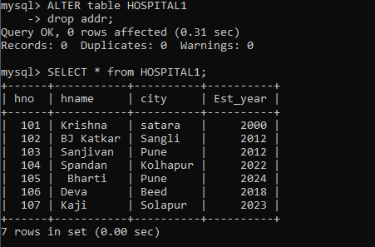

**Q 2.Display Doctor name, hospital name and speacilty of doctors from “pune city”.**

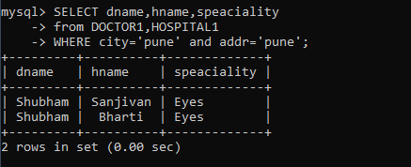

**Q 3. Display the names of the hospitals which are located at ‘pune’ city.**

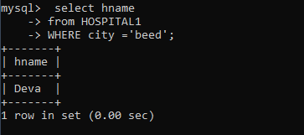

**Q 4. Display the names of the doctors who are working in ‘Thane’ and name is’Amit’.**

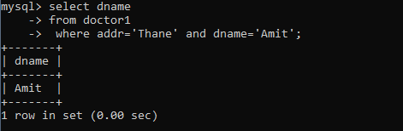

**Q 5.Display the speacility of the doctors who working in ‘mumbai’ hospital.**

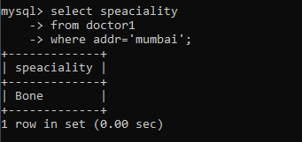

**Q 6. Give the count of doctor’s hospital wise which are located at ’ Mumbai’.**

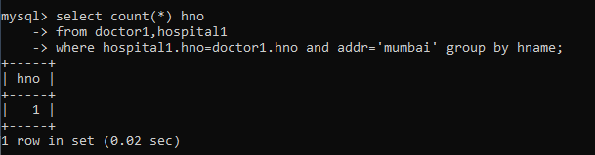

**Q 7. Update an address of doctor to “ Amit“ whose hospital is” Pimpari’’.**

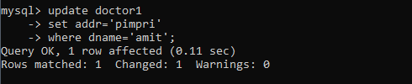

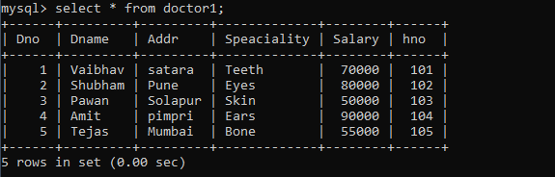

**Q 8. Display doctor details whose speaciality is skin and whole belong to hospital from Solapur.**

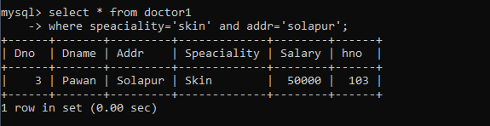

**Q 9. Update an address of hospital ‘dubai’ whose hospital is established in 2000.**

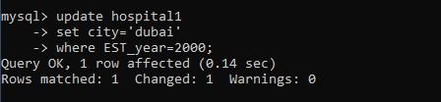

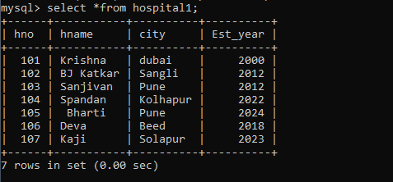

**Q 10. Display Total salary of all doctors hospitalwise**

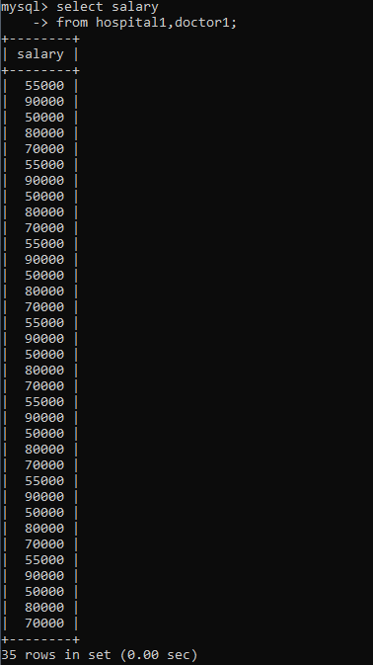

**TASK 4**

mysql> create database project;

Query OK, 1 row affected (0.21 sec)

mysql> use project;

Database changed

mysql> create table project(pno int primary key,pname varchar(255) not null,start_date varchar(255),budget int,status varchar(50),dno int);

Query OK, 0 rows affected (1.04 sec)

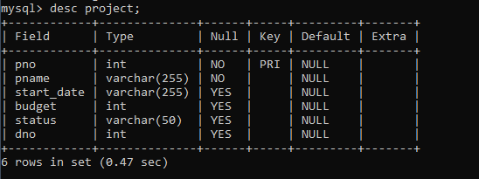

mysql> insert into project values(1,'Dry fruit System','04-10-2022',3000,'c',101);

Query OK, 1 row affected (0.15 sec)

mysql> insert into project values(2,'Event Management System','21-10-2021',1000,'p',102);

Query OK, 1 row affected (0.11 sec)

mysql> insert into project values(3,'Food System','04-09-2017',6000,'i',103);

Query OK, 1 row affected (0.10 sec)

mysql> insert into project values(4,'restaurant management','09-09-2023',1500,'p',104);

Query OK, 1 row affected (0.10 sec)

mysql> insert into project values(5,'car shoroom','05-10-2022',5000,'c',105);

Query OK, 1 row affected (0.10 sec)

mysql> insert into project values(6,'fruit shop','04-07-2016',4000,'i',106);

Query OK, 1 row affected (0.14 sec)

mysql> insert into project values(7,'nurcery system','07-07-2022',7000,'c',107);

Query OK, 1 row affected (0.10 sec)

mysql> insert into project values(8,'room management','04-10-2000',9000,'p',108);

Query OK, 1 row affected (0.10 sec)

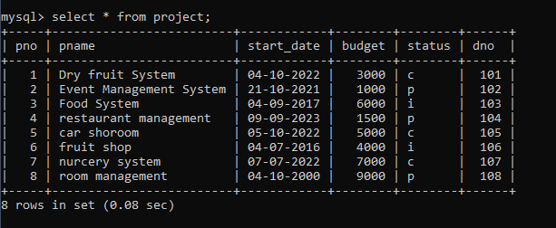

mysql> create database department1;

Query OK, 1 row affected (0.14 sec)

mysql> create table department1(dno int primary key,dname varchar(50),hod varchar(50),loc varchar(255),pno int);

Query OK, 0 rows affected (2.22 sec)

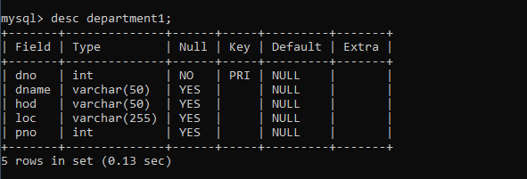

mysql> insert into department1 values(101,'bca','shinde','dahiwadi',1);

Query OK, 1 row affected (0.28 sec)

mysql> insert into department1 values(102,'bcs','mane','mankarnwadi',2);

Query OK, 1 row affected (0.12 sec)

mysql> insert into department1 values(103,'mca','mohite','pune',3);

Query OK, 1 row affected (0.12 sec)

mysql> insert into department1 values(104,'mcs','jagadale','phaltan',4);

Query OK, 1 row affected (0.11 sec)

mysql> insert into department1 values(105,'msc','bhosle','rajwadi',5);

Query OK, 1 row affected (0.06 sec)

mysql> insert into department1 values(106,'bsc','bagal','vaduj',6);

Query OK, 1 row affected (0.11 sec)

mysql> insert into department1 values(107,'bvoc','kamble','karad',7);

Query OK, 1 row affected (0.11 sec)

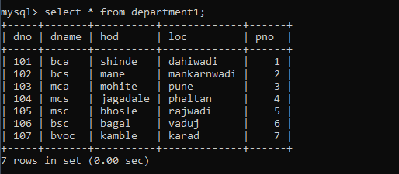

**1.Drop loc column from department table.**

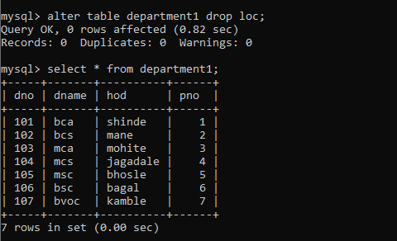

**2 .Display the details of project whose start_date is before one month and status is “Progressive”**

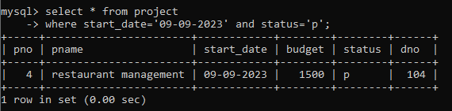

**3. Display the names of project and department who are worked on projects whose status is ‘Completed’**

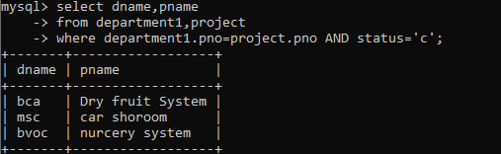

**4.Display total budget of each department.**

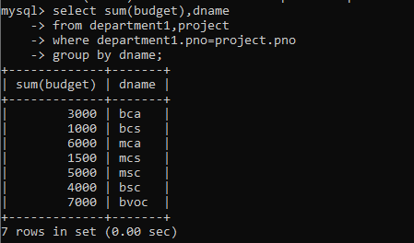

**5. Display incomplete project of each department.**

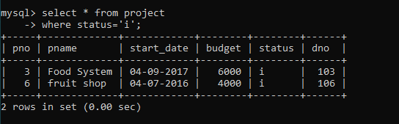

**6. Display all project working under 'Mr. Desai'.**

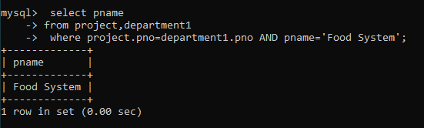

**7. Display department wise HOD.**

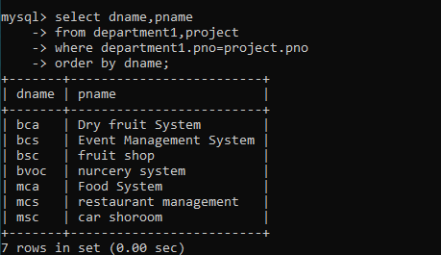

**8. Display project details where project name start with E and whose budget is >500 in descending order.**

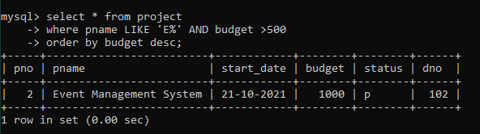

**9. Display the project detials whose having highest budget**

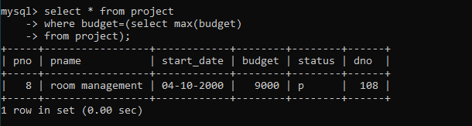

**TASK 5**

**Many To Many**

mysql> create database customer;

Query OK, 1 row affected (0.01 sec)

mysql> use customer;

Database changed

mysql> create table customer(cust_no int primary key,cust_name varchar(255),

address varchar(255),city varchar(255));

Query OK, 0 rows affected (0.04 sec)

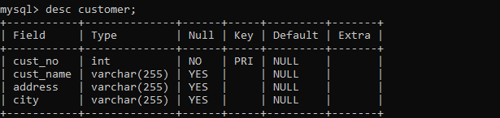

mysql> insert into customer values(1,'vidhya','xyz','pune'),(2,'pranita','mankarnwadi','satara'),(3,'anuu','dahiwadi','satara'),(4,'aishu','balaji nagar','pune'),(5,'neha','dadar','mumbai');

Query OK, 5 rows affected (0.01 sec)

Records: 5 Duplicates: 0 Warnings: 0

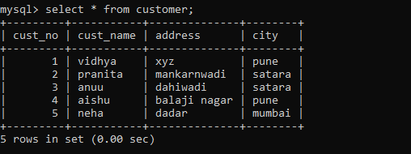

mysql> create table loan(loan_no int primary key,loan_amt int);

Query OK, 0 rows affected (0.03 sec)

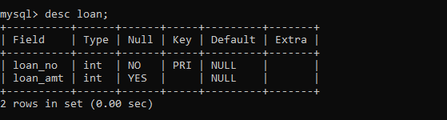

mysql> insert into loan values(101,50000),(102,6000),(103,30000),(104,4000),

(105,70000);

Query OK, 5 rows affected (0.01 sec)

Records: 5 Duplicates: 0 Warnings: 0

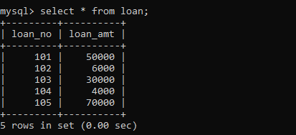

mysql> create table cust_loan(cust_no int references customer(cust_no),loan_

no int references loan(loan_no),loan_status varchar(255));

Query OK, 0 rows affected (0.03 sec)

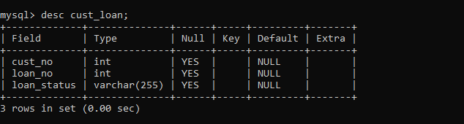

mysql> insert into cust_loan values(1,101,'completed'),(2,102,'process'),(3,

103,'imcompleted'),(4,104,'process'),(5,105,'completed');

Query OK, 5 rows affected (0.01 sec)

Records: 5 Duplicates: 0 Warnings: 0

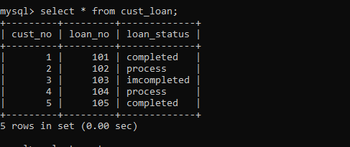

**1)select the details of customer whose loan_amt<10000**

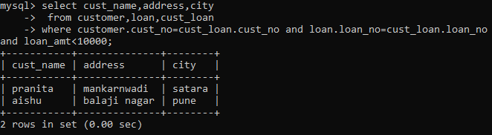

**2) list all customer whose name start with D character.**

